Local History Topic Knowledge Organiser | Spring Term 2020 | Year 2 and 3: Chestnut, Rowan and Cedar Classes

Key buildings |  |  |  |  | Map |  |  |  |  |  | Vocabulary
All Saints Church 1350 |  | 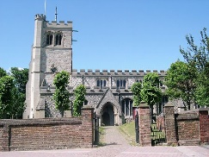 |  |  | 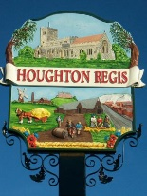  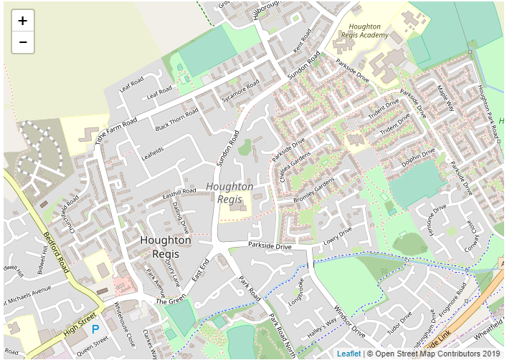 |  |  |  |  |  | - Town – Built up area with a local government  - Village – a group of houses with some facillites  - County – division of England into areas  - Church – building used for Christian worship  - Houghton Hall – local historical building  - Houghton Regis – the name of our town  - Medieval – a period of time (middle ages)  - Norman – a period of time before the middle ages (1066 – 1485)  - Straw plaiting – major occupation in 1600s and beyond  - Settlement – area area people have built a community
The Red House 1600s |  | 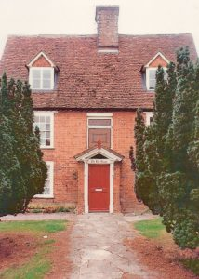
Houghton Hall 1720 |  | 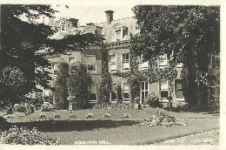
The Crown 1800s |  | 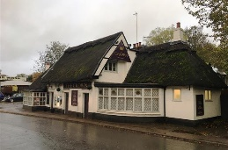
Timeline
1066 | 1086 |  | 1121 | 1300s |  | 1350 | 1654 | 1720 | 1857 | 1918 |  | 1939 | 1970s | 1979
Settlement named Kings Houghton | Mentioned in the Doomsday Book |  | Henry I gifts land to Hugh de Gurnay | Farming was main occupation |  | All Saints Church was built | Thomas Whitehead died leaving money to begin a school | Houghton Hall was built | National School est. | 29 Houghton men lost at war |  | Evacuees came to Houghton | Parkside estate built | Hawthorn Park School Built

