Calculation Policy
October 2019

This calculation policy outlines the calculation methods that should be taught in each year group. However, these should be used as guidelines to support the planning and progression principles embedded within the national curriculum and should not be used to limit the progression of learning nor to move a pupil on too early if their understanding of the previous conceptual stage is not embedded.

Early Years Foundation Stage
Year |  | Mental calculation | Written Calculation | Default for ALL children
 | Overview | Children will continue onto recognising numerals and practising number formation from 1-20. Children count reliably with numbers from 0 to 20. Place them in order and say which number is one more or one less than a given number. Using quantities and objects, they add and subtract two single-digit numbers and count on or back to find the answer. They solve problems, including doubling, halving and sharing. Children also create patterns using difference objects and begin to recognise patterns. The following are possible resources that can be used to access the Early Learning Goals: Magnetic numbers, printing numbers, painting numbers, chalk, numicon, unifix, multilink, compare bears / camels, beads, keys, number lines, number tracks, cotton reels and any movable objects.
Year |  | Mental calculation | Written Calculation | Default for ALL children
Early Years | Addition | Use mathematical vocabulary and demonstrate methods of recording, using standard notation where appropriate.  Number bonds (‘story of’ 5, 6, 7, 8, 9 and 10) | Using quantities and objects, they add two single-digit numbers and count on or back to find the answer. 3+2=  Begin to use appropriate symbols for addition (+ and =) when writing simple calculations. | Number rhymes/ stories/ songs – Action rhymes.  Counting in ones up to twenty and beyond.  Counting in tens.  Counting forwards and backwards, starting counting from any number (different starting points.  Also use money in role play area etc.
 | Subtraction | Using quantities and objects, subtract two single-digit numbers and count on or back to find the answer.  Count back in ones from 20.  Kims game – cover up blocks how many have I taken away. | Subtraction as take away (using objects or drawing and crossing out). 6 – 2 = | Number rhymes/ stories/ songs – Action rhymes.  Counting back in ones.  Counting back in ones from 20 to 0
Early Years | Multiplication | Solve problems, including doubling, halving and sharing.  Talk about the methods children use to answer a problem they have posed, e.g. ‘Get one more, and then we will both have two.’  Encourage children to extend problems, e.g. “Suppose there were three people to share the bricks between instead of two.” | Practical ways of doubling Find that many again. I have 3 apples, can you double the number of apples? There are 6 apples in total. | Number rhymes/ stories/ songs – Action rhymes.  Will be counting in 2s and counting in 5s at the end of reception – at least being introduced into this, counting in 10s to 100.
 | Division | Solve problems, including halving and sharing. | Sharing concrete objects:  Give half of these pencils to the next table.  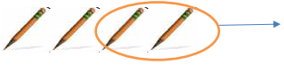  Share these strawberries between 3 children– how many will they have each?  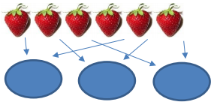 | Number rhymes/ stories/ songs – Action rhymes.
Year |  | Mental calculation | Written Calculation | Default for ALL children
 | Overview for KS1 | Children in Years 1 and 2 will be given a really solid foundation in the basic building blocks of mental and written arithmetic. Through being taught place value, they will develop an understanding of how numbers work, so that they are confident in 2-digit numbers and beginning to read and say numbers above 100. A focus on number bonds, first via practical hands-on experiences using manipulatives, and subsequently using memorisation techniques, enables a good grounding in these crucial facts, and ensures that all children leave Y2 knowing the pairs of numbers which make all the numbers up to 10 at least. They will also have experienced and been taught pairs to 20. Their knowledge of number facts enables them to add several single-digit numbers, and to add/subtract a single digit number to/from a 2-digit number. Another important conceptual tool is their ability to add/subtract 1 or 10, and to understand which digit changes and why. This understanding is extended to enable children to add and subtract multiples of ten to and from any 2-digit number. The most important application of this knowledge is their ability to add or subtract any pair of 2-digit numbers by counting on or back in tens and ones. Children may extend this to adding by partitioning numbers into tens and ones. Children will be taught to count in 2s, 3s, 5s and 10s, and will have related this skill to repeated addition. Engaging in a practical way, using manipulatives, with the concept of repeated addition and the use of arrays enables children to develop a preliminary understanding of multiplication, and asking them to consider how many groups of a given number make a total will introduce them to the idea of division. They will also be taught to double and halve numbers and will thus experience scaling up or down as a further aspect of multiplication and division. Fractions will be introduced as numbers and as operators, specifically in relation to halves, quarters and thirds.
Year 1 | Addition | Number bonds (‘story of’ 5, 6, 7, 8, 9 and 10)  Count on in ones from a given 2-digit number  Add two single-digit numbers  Add three single-digit numbers spotting doubles or pairs to 10  Count on in tens from any given 2-digit number  Add 10 to any given 2-digit number  Use number facts to add single-digit numbers to two-digit numbers, e.g. use 4 + 3 to work out 24 + 3, 34 + 3…  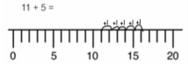  Add by putting the larger number first | Write and interpret mathematical statements using symbols  e.g. addition (+), subtraction (-), and equals (=). Children begin to add units together using physical objects e.g. They begin to record by drawing pictures/marks.  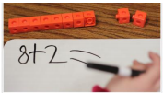  Begin to compare (what’s the same / different) for commutative sums:  e.g. 3 + 7 = 7 + 3  Children are shown how to add using a number line:  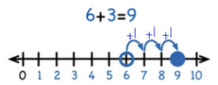  Children begin to add numbers that bridge 10 using the same strategies.  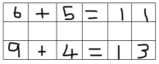 | Pairs with a total of 10  Counting in ones  Counting in tens  Count on 1 from any given 2-digit number
 | Subtraction | Number bonds (‘story of’ 5, 6, 7, 8, 9 and 10)  Count back in ones from a given 2-digit number  Subtract one single-digit number from another  Count back in tens from any given 2-digit number  Subtract 10 from any given 2-digit number  Use number facts to subtract single-digit numbers from two-digit numbers, e.g. use 7 – 2 to work out 27 – 2, 37 – 2… | Write and interpret mathematical statements using symbols e.g. addition (+), subtraction (-), and equals (=).  Children begin to subtract units from a large group using physical objects:  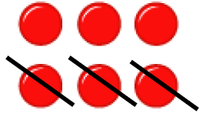  Children begin to subtract numbers that bridge 10 using the same strategies. A 1-digit number is subtracted from a 2 digit number.  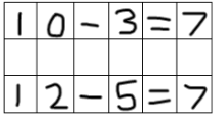  Number lines are used to show the jumps backwards and the number getting smaller with subtraction:  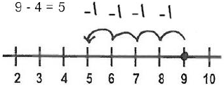 | Pairs with a total of 10  Counting back in ones from 20 to 0  Counting back in tens from 100 to 0  Count back 1 from any given 2-digit number – within the ten before bridging the ten.
 | Multiplication | Begin to count in 2s, 5s and 10s  Begin to say what three 5s are by counting in 5s or what four 2s are by counting in 2s, etc.  Double numbers to 10 | Represent as repeated addition in preparation for Year 2.  e.g. 3 + 3 + 3 + 3 = 12  Children record each number sentence by drawing the array:  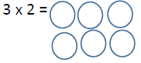 | Begin to count in 2s and 10s  Double numbers to 5 using fingers
 | Division | Begin to count in 2s, 5s and 10s  Find half of even numbers to 12 and know it is hard to halve odd numbers  Find half of even numbers by sharing  Begin to use visual and concrete arrays or ‘sets of’ to find how many sets of a small number make a larger number. | Pictorial representations of practical activities of sharing and grouping.  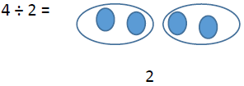 | Begin to count in 2s and 10s  Find half of even numbers by sharing
Year 2  Year 2 | Addition | Number bonds – knowing all the pairs of numbers which make all the numbers to 12, and pairs with a total of 20  Count on in ones and tens from any given 2-digit number  Add two or three single-digit numbers  Add a single-digit number to any 2-digit number using number facts, including bridging multiples of 10. (E.g. 45 + 4, 38 + 7)  Add 10 and small multiples of 10 to any given 2-digit number  Add any pair of 2-digit numbers | Children move on to bridge 10 whilst still adding units e.g. 27 + 5 =  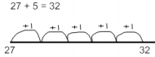  Children will build on their number knowledge by partitioning 2 digit numbers using concrete methods such as dienes blocks into tens and units so they are ready for the next step:  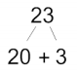  Begin to record expanded addition in columns to support place value and prepare for formal written methods with larger numbers.  e.g. 40 + 5  20 + 3 +  60 + 8 = 68 | Know pairs of numbers which make each total up to 10  Add two single digit numbers  Add a single-digit number to a 2-digit number by counting on in ones  Add 10 and small multiples of 10 to a 2-digit number by counting on in tens
 | Subtraction | Number bonds – knowing all the pairs of numbers which make all the numbers to 12  Count back in ones and tens from any given 2-digit number  Subtract a single-digit number from any 2-digit number using number facts, including bridging multiples of 10, e.g. 56 – 3, 53 – 5.  Subtract 10 and small multiples of 10 from any given 2-digit number  Subtract any pair of 2-digit numbers by counting back in tens and ones or by counting up. | Use jottings to support informal methods, including the empty number line, and recording on a 100 square.  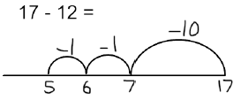  Continue to increase difficulty by subtracting larger numbers with multiple tens.  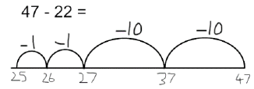  Use empty number lines to count on for subtraction also. | Know pairs of numbers which make each total up to 10  Subtract a single-digit number from a 2-digit number by counting back in ones – within the ten before bridging the ten.  Subtract 10 and small multiples of 10 from a 2-digit number by counting back in tens
 | Multiplication | Count in 2s, 5s and 10s  Begin to count in 3s.  Begin to understand that multiplication is repeated addition and to use arrays (E.g. 3 x 4 is three rows of 4 dots)  Begin to learn the 2x, 3x, 5x and 10x tables, seeing these as ‘lots of’, e.g. 5 lots of 2, 6 lots of 2, 7 lots of 2, etc.  Double numbers up to 20  Begin to double multiples of 5 to 100  Begin to double two-digit numbers less than 50 with 1s digits of 1, 2, 3 4 or 5 | Write and interpret mathematical statements using symbols  e.g. multiplication (x), division (÷), and equals (=).  Repeated addition is used as a written method for multiplication:  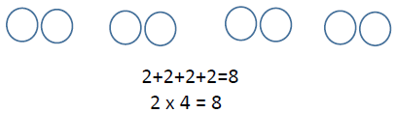  Children will be shown that multiplication of two numbers can be done in any order (commutative) and will use arrays to represent this.  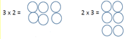 | Count in 2s, 5s and 10s  Begin to use and understand simple arrays, e.g. 2 x 4 is two lots of four buns.  Double numbers up to 10  Double multiples of 10 to 50
 | Division | Count in 2s, 5s and 10s  Begin to count in 3s  Using fingers, say where a given number is in the 2s, 5s or 10s count. (E.g. 8 is the fourth number when I count in twos.)  Relate division to grouping. (E.g. how many groups of five in fifteen?)  Halve numbers to 20  Begin to halve numbers to 40 and multiples of 10 to 100  Find ½, ¹/₃, ¼ and ¾ of a quantity of objects and of amounts (whole number answers) | Write and interpret mathematical statements using symbols  e.g. multiplication (x), division (÷), and equals (=).  Use apparatus such as beaded lines to share and group, then begin to use arrays to show the groups of division:  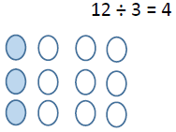 | Count in 2s, 5s and 10s  Say how many rows in a given array. (E.g. how many rows of 5 in an array of 3 x 5)  Halve numbers to 12  Find ½ of amounts

Lower Key stage 2
 | Overview of LKS2 | In lower KS2, children build on the concrete and conceptual understandings they have gained in the KS1 to develop a real mathematical understanding of the four operations. In addition and subtraction, they are taught to use place value and number facts to add and subtract numbers mentally and will develop a range of strategies. In particular, they will learn to add and subtract multiples and near multiples of 10, 100 and 1000, and will become fluent in complementary addition as an accurate means of achieving fast and accurate answers to 3-digit subtractions. Standard written methods for adding larger numbers are taught, learned and consolidated, and written column subtraction is also introduced. This key stage is also the period during which all the multiplication and division facts are thoroughly memorised, including all facts up to the 12 x 12 table. Efficient written methods for multiplying or dividing a 2-digit or 3-digit number by as single-digit number are taught, as are mental strategies for multiplication or division with large but friendly numbers, e.g. when dividing by 5 or multiplying by 20. Children will develop their understanding of fractions, learning to reduce a fraction to its simplest form as well as finding non-unit fractions of amounts and quantities. The concept of a decimal number is introduced and children consolidate a firm understanding of one-place decimals, multiplying and dividing whole numbers by 10 and 100. Manipulatives should continue to be used where they support or add value to learning.
Year 3  Year 3 | Addition | Know pairs with each total to 20  Know pairs of multiples of 10 with a total of 100  Add any two 2-digit numbers by counting on in 10s and 1s or by using partitioning  Add multiples and near multiples of 10 and 100  Perform place value additions without a struggle. (E.g. 300 + 8 + 50 = 358)  Use place value and number facts to add a 1-digit or 2-digit number to a 3-digit number. (E.g. 104 + 56 is 160 since 104+50=154 and 6+4=10 and 676 + 8 is 684 since 8=4+4 and 76+4+4=84)  Add pairs of ‘friendly’ 3-digit numbers, e.g. 320 + 450  Begin to add amounts of money using partitioning. | Use expanded column addition to add two or three 3-digit numbers or three 2-digit numbers  Begin to use compact column addition to add numbers with three digits.  e.g. 34  25 +  59  Children start using the partitioning column method to solve problems that bridge the tens and hundreds boundaries.  337 + 188 = 525  300 + 30 + 7  100 + 80 + 8  400 + 110 + 15 = 525  Children use expanded column method for addition:  343  +116  400  50  + 9  459  Children then introduced to ‘carrying’ which happens when bridging in the column method.  245 + 84 = 329  245  + 84  329  1  Begin to add like fractions. (e.g. ³/₈ + ¹/₈ + ¹/₈)  Recognise fractions that add to 1. (e.g. ¼ + ¾ or ³/₅ + ²/₅) | Know pairs of numbers which make each total up to 10, and which total 20  Add two 2-digit numbers by counting on in tens and ones (E.g. 56 + 35 is 56 + 30 and then add the 5)  Understand simple place value additions: 200 + 40 + 5 = 245  Use place value to add multiples of 10 or 100
 | Subtraction | Know pairs with each total to 20  Subtract any two 2-digit numbers  Perform place value subtractions without a struggle. (E.g. 536 – 30 = 506, etc.)  Subtract 2-digit numbers from numbers >100 by counting up. (E.g. 143 – 76 is done by starting at 76, add 4 (80) then add 20 (100) then add 43 making the difference a total of 67)  Subtract multiples and near multiples of 10 and 100  Subtract, when appropriate, by counting back or taking away, using place value and number facts.  Find change from £1, £5 and £10. | Use counting up as an informal written strategy for subtracting pairs of three-digit numbers, e.g.  423 – 357 is  +3 +40 +23 = 66  357 360 400 423  Children will now have the mental skills required to approach the partitioning column method of subtraction. At first they should attempt this where no exchanging is required. Here is an example for 89 – 35 = 54.  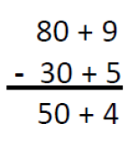  Begin to subtract like fractions. (E.g. ⁷/₈ - ³/₈) | Know pairs of numbers which make each total up to 10, and which total 20. Subtract within the ten before bridging the ten.  Count up to subtract 2-digit numbers: 72 – 47 is  +3 +10 +10 +2 = 25  47 50 60 70 2  Subtract multiples of 5 from 100 by counting up  +5 +60 = 65  35 40 100  Subtract multiples of 10 and 100
 | Multiplication | Know by heart all the multiplication facts in the 2x, 3x, 4x, 5x, 8x and 10x tables  Multiply whole numbers by 10 and 100  Recognise that multiplication is commutative  Use place value and number facts in mental multiplication. (E.g. 30 x 5 is 15 x 10)  Partition teen numbers to multiply by a single-digit number. (E.g. 3 x 14 as 3 x 10 and 3 x 4)  Double numbers up to 50 | Use partitioning (grid multiplication) to multiply 2-digit and 3-digit numbers by ‘friendly’ single digit numbers.  Use it in the form of an array:  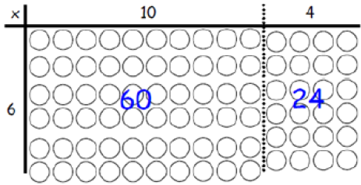  Multiplication grid method requires good organization but also a solid understanding of partitioning and multiplication facts:  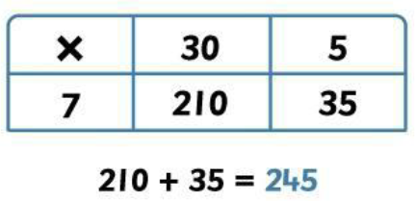 | Know by heart the 2x, 3x, 5x and 10x tables  Double given tables facts to get others  Double numbers up to 25 and multiples of 5 to 50
 | Division | Know by heart all the division facts derived from the 2x, 3x, 4x, 5x, 8x and 10x tables.  Divide whole numbers by 10 or 100 to give whole number answers  Recognise that division is not commutative.  Use place value and number facts in mental division. (E.g. 84 ÷ 4 is half of 42)  Divide larger numbers mentally by subtracting the tenth multiple, including those with remainders. (E.g. 57 ÷ 3 is 10 + 9 as 10x3=30 and 9x3=27)  Halve even numbers to 100, halve odd numbers to 20 | Perform divisions just above the 10th multiple using the written layout and understanding how to give a remainder as a whole number.  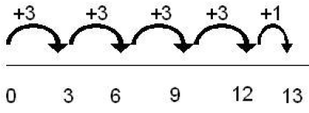  Use chunking on a number line:  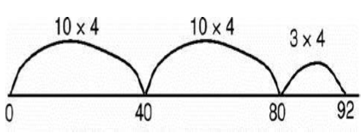  Move onto short division when confident with chunking:  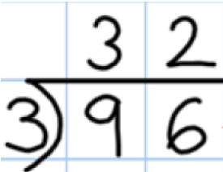  Find unit fractions of quantities and begin to find non-unit fractions of quantities | Know by heart the division facts derived from the 2x, 3x, 5x and 10x tables  Halve even numbers up to 50 and multiples of ten to 100  Perform divisions within the tables including those with remainders, e.g. 38 ÷ 5.
Year 4  Year 4  Year 4 | Addition | Add any two 2-digit numbers by partitioning or counting on  Know by heart/quickly derive number bonds to 100 and to £1  Add to the next hundred, pound and whole number. (E.g. 234 + 66 = 300, 3.4 + 0.6 = 4)  Perform place value additions without a struggle. (E.g. 300 + 8 + 50 + 4000 = 4358)  Add multiples and near multiples of 10, 100 and 1000.  Add £1, 10p, 1p to amounts of money  Use place value and number facts to add 1-, 2-, 3-and 4-digit numbers where a mental calculation is appropriate’. (E.g. 4004 + 156 by knowing that 6+4=10 and that 4004+150= 4154 so total is 4160) | Column addition for 3-digit and 4-digit numbers:  4267 + 1584 = 5851  4267  + 1584  5851  11  Add like fractions, e.g. ³/₅ + ⁴/₅ = ⁷/₅ = 1 ²/₅.  Be confident with fractions that add to 1 and fraction complements to 1. (E.g. ²/₃ + ? = 1) | Add any 2-digit numbers by partitioning or counting on  Number bonds to 20  Know pairs of multiples of 10 with a total of 100  Add friendly larger numbers using knowledge of place value and number facts  Use expanded column addition to add larger numbers as a precursor to compact column addition where difficulties are encountered.
 | Subtraction | Subtract any two 2-digit numbers  Know by heart/quickly derive number bonds to 100  Perform place value subtractions without a struggle. (E.g. 4736 – 706 = 4030, etc.)  Subtract multiples and near multiples of 10, 100 and 100  Subtract by counting up. (E.g. 503 – 368 is done by adding: 368 +2 +30 +100 +3 so we added 135)  Subtract, when appropriate, by counting back or taking away, using place value and number facts.  Subtract £1, 10p, 1p from amounts of money  Find change from £10, £20 and £50. | Use expanded column subtraction for 3-digit and 4-digit numbers - using the language of ‘exchange’ and denes equipment to support this concept when bridging through a ten.  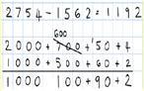  When the expanded column subtraction is mastered then move onto the compacted column subtraction method:  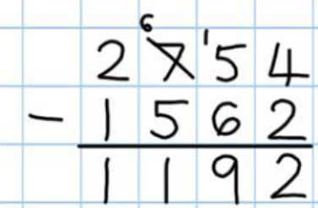  Use complementary addition to subtract amounts of money, and for subtractions where the larger number is a near multiple of 1000 or 100  E.g. 2002 – 1865 is  +5 +30 +102 = 137  1865 1870 1900 2002  Subtract like fractions, e.g. ¼ + ¹/₈ = ³/₈  Use fractions that add to 1 to find fraction complements to 1, e.g. 1 – ²/₃ = ¹/₃ | Use counting up with confidence to solve most subtractions, including finding complements to multiples of 100. (E.g. 512 – 287 is done by  +3 +10 +100 +100 +12 = 225  287 290 300 400 500 512  67 + ? = 100 +3 +30 = 33  67 70 100
 | Multiplication | Know by heart all the multiplication facts up to 12 x 12.  Recognise factors up to 12 of two-digit numbers.  Multiply whole numbers and one-place decimals by 10, 100, 1000  Multiply multiples of 10, 100, 1000 by single digit numbers. (E.g. 300 x 6 or 4000 x 8)  Use understanding of place value and number facts in mental multiplication. (E.g. 36 x 5 is half of 36 x 10 and 50 x 60 = 3000)  Partition 2-digit numbers to multiply by a single-digit number mentally. (E.g. 4 x 24 as 4 x 20 and 4 x 4)  Multiply near multiples using rounding. (E.g. 33 x 19 as 33 x 20 – 33)  Find doubles to double 100 and beyond using partitioning  Begin to double amounts of money. (E.g. £35.60 doubled = £71.20.) | The grid method is extended in year 4 so children will now multiply 3 digit numbers by 1 digit numbers.  Use a vertical written method to multiply a one-digit by a 3-digit number (ladder)  e.g. 246  5 x  30 5 x 6  200 4 x 40  1000 5 x 200  1230  Use an efficient written method to multiply a 2-digit number by a number between 10 and 20 by partitioning (grid method) | Know by heart multiplication tables up to 10 x 10  Multiply whole numbers by 10 and 100  Use grid method to multiply a 2-digit or a 3-digit number by a number up to and including 6
 | Division | Know by heart all the division facts up to 144 ÷ 12.  Divide whole numbers by 10, 100 to give whole number answers or answers with one decimal place  Divide multiples of 100 by 1-digit numbers using division facts. (E.g. 3200 ÷ 8 = 400)  Use place value and number facts in mental division. (E.g. 245 ÷ 20 is double 245 ÷ 10 )  Divide larger numbers mentally by subtracting the 10th or 20th multiple as appropriate. (E.g. 156 ÷ 6 is 20 + 6 as 20x6=120 and 6x6=36)  Find halves of even numbers to 200 and beyond using partitioning  Begin to halve amounts of money. (E.g. Half of £52.40 = £26.20) | Use a written method to divide a 2-digit or a 3-digit number by a single-digit number.  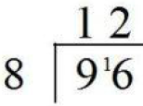  Give remainders as whole numbers.  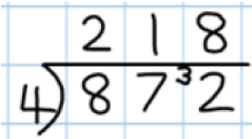  Begin to reduce fractions to their simplest forms.  Find unit and non-unit fractions of larger amounts. | Know by heart all the division facts up to 100 ÷ 10.  Divide whole numbers by 10 and 100 to give whole number answers or answers with one decimal place  Perform divisions just above the 10th multiple using the written layout and understanding how to give a remainder as a whole number.  Find unit fractions of amounts

Upper Key stage 2
 | Overview of UKS2 | Children move on from dealing mainly with whole numbers to performing arithmetic operations with both decimals and fractions. They consolidate their use of written procedures in adding and subtracting whole numbers with up to 6 digits and also decimal numbers with up to two decimal places. Mental strategies for adding and subtracting increasingly large numbers will also be taught. These draw upon children’s robust understanding of place value and knowledge of number facts. Efficient and flexible strategies for mental multiplication and division are taught and practised, so that children can perform appropriate calculations even when the numbers are large, such as 40,000 x 6 or 40,000 ÷ 8. In addition, it is Y5 and Y6 that children extend their knowledge and confidence in using written algorithms for multiplication and division. Fractions and decimals are also added, subtracted, divided and multiplied, within the bounds of children’s understanding of these more complicated numbers, and they will also calculate simple percentages and ratios. Negative numbers will be added and subtracted. Manipulatives should continue to be used where they add value to the learning. Children should be confident in their calculation methods and be able to apply them in investigations and use them to predict, justify and reason mathematically.
Year 5 | Addition | Know numbers bonds to 1 and to the next whole number  Add to the next 10 from a decimal number, e.g. 13·6 + 6·4 = 20  Add numbers with two significant digits only, using mental strategies. (E.g. 3.4 + 4.8 or 23,000 + 47,000)  Add one or two-digit multiples of 10, 100, 1000, 10,000 and 100,000. (E.g. 8000 + 7000 or 600,000 + 700,000)  Add near multiples of 10, 100, 1000, 10,000 and 100,000 to other numbers. (E.g. 82,472 + 30,004)  Add decimal numbers which are near multiples of 1 or 10, including money. (E.g. 6·34 + 1·99 or £34·59 + £19·95)  Use place value and number facts to add two or more friendly numbers including money and decimals. (E.g. 3 + 8 + 6 + 4 + 7, 0.6 + 0.7 + 0.4, or 2,056 + 44) | Use column addition to add two or three whole numbers with up to 5 digits  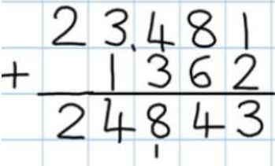  Use column addition to add any pair of two-place decimal numbers including amounts of money.  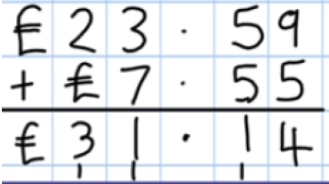  Begin to add related fractions using equivalences. (E.g. ½ + ¹/₆ = ³/₆ + ¹/₆)  Choose the most efficient method in any given situation | Add numbers with only 2-digits which are not zeros, e.g. 3.4 + 5.8  Derive swiftly and without any difficulty number bonds to 100  Add friendly large numbers using knowledge of place value and number facts  Use expanded column addition to add larger numbers as a precursor to compact column addition where difficulties are encountered.
 | Subtraction | Subtract numbers with two significant digits only, using mental strategies. (E.g. 6.2 – 4.5 or 72,000 – 47,000)  Subtract one or two-digit multiples of 100, 1000, 10,000 and 100,000. (E.g. 8000 – 3000 or 600,000 – 200,000)  Subtract one or two digit near multiples of 100, 1000, 10,000 and 100,000 from other numbers. (E.g. 82,472 – 30,004)  Subtract decimal numbers which are near multiples of 1 or 10, including money. (E.g. 6·34 – 1·99 or £34·59 – £19·95)  Use counting up subtraction, with knowledge of number bonds to 10/100 or £1, as a strategy to perform mental subtraction. (E.g. £10 - £3.45 or 1000 – 782]  Recognise fraction complements to 1 and to the next whole number. (E.g. 1 ²/₅ + ³/₅ = 2) 4 – 5 | Use compact or expanded column subtraction to subtract numbers with up to 5 digits - using the language of ‘exchange’ and denes equipment to support this concept when bridging through a ten.  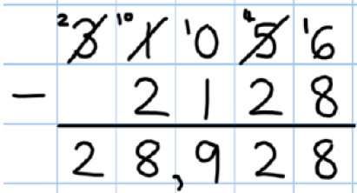  Use complementary addition for subtractions where the larger number is a multiple or near multiple of 1000.  Use complementary addition for subtractions of decimals with up to two places incl. amounts of money  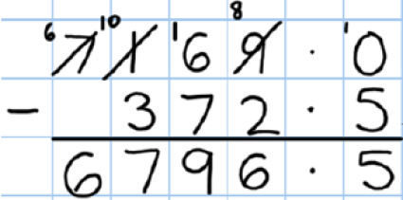  Begin to subtract related fractions using equivalences. (E.g. ½ – ¹/₆ = ²/₆)  Choose the most efficient method in any given situation | Derive swiftly and without difficulty number bonds to 100  Use counting up with confidence to solve most subtractions, including finding complements to multiples of 1000. (E.g. 3000 – 2387 is done by  +3 +10 +600 = 613  2387 2390 2400 3000
 | Multiplication | Know by heart all the multiplication facts up to 12 x 12.  Multiply whole numbers and one-and two-place decimals by 10, 100, 1000, 10,000  Use knowledge of factors and multiples in multiplication. (E.g. 43 x 6 is double 43 x 3, and 28 x 50 is ½ of 28 x 100 = 1400)  Use knowledge of place value and rounding in mental multiplication. (E.g. 67 x 199 as 67 x 200 – 67)  Use doubling and halving as a strategy in mental multiplication. (E.g. 58 x 5 = half of 58 x 10, and 34 x 4 is 34 doubled twice)  Partition 2-digit numbers, including decimals, to multiply by a single-digit number mentally. (E.g. 6 x 27 as 6 x 20 (120) plus 6 x 7 (42) making 162 or 6.3 x 7 as 6 x 7 plus 0.3 x 7)  Double amounts of money by partitioning. (E.g. £37.45 doubled = £37 doubled (£74) plus 45p doubled (90p) £74.90) | Use short multiplication to multiply a 1-digit number by a number with up to 4 digits  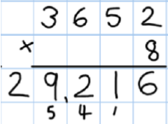  Use long multiplication to multiply 3-digit and 4-digit number by a number between 11 and 20  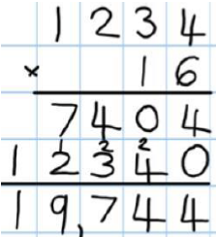  Choose the most efficient method in any given situation.  Find simple percentages of amounts 9e.g. 10%, 5%, 20%, 155 and 50%)  Begin to multiply fractions and mixed numbers by whole numbers ≤ 10, e.g. 4 × ²/₃ = ⁸/₃ = 2²/₃. | Know multiplication tables to 11 x 11  Multiply whole numbers and one-place decimals by 10, 100 and 1000  Use knowledge of factors as aids to mental multiplication. (E.g. 13 x 6 = double 13 x 3 and 23 x 5 is ½ of 23 x 10)  Use grid method to multiply numbers with up to 4-digits by one-digit numbers.  Use grid method to multiply 2-digit by 2-digit numbers.
 | Division | Know by heart all the division facts up to 144 ÷ 12.  Divide whole numbers by 10, 100, 1000, 10,000 to give whole number answers or answers with 1, 2 or 3 decimal places  Use doubling and halving as mental division strategies. (E.g. 34 ÷ 5 is (34 ÷ 10) x 2)  Use knowledge of multiples and factors, also tests for divisibility ,in mental division. (E.g. 246 ÷ 6 is 123 ÷ 3 and we know that 525 divides by 25 and by 3)  Halve amounts of money by partitioning. (E.g. Half of £75.40 = half of £75 (37.50) plus half of 40p (20p) which is £37.70)  Divide larger numbers mentally by subtracting the 10th or 100th multiple as appropriate. (E.g. 96 ÷ 6 is 10 + 6, as 10 × 6 = 60 and 6 × 6 = 36; 312 ÷ 3 is 100 + 4 as 100 x 3 = 300 and 4 x 3 = 12)  Reduce fractions to their simplest form. | Use short division to divide a number with up to 4 digits by a number ≤12.  Give remainders as whole numbers or as fractions.  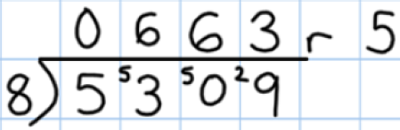  Find non-unit fractions of large amounts.  Turn improper fractions into mixed numbers and vice versa.  Choose the most efficient method in any given situation | Know by heart division facts up to 121 ÷ 11  Divide whole numbers by 10, 100 or 1000 to give answers with up to one decimal place.  Use doubling and halving as mental division strategies  Use efficient chunking to divide numbers ≤ 1000 by 1-digit numbers.  Find unit fractions of 2 and 3-diigt numbers
Year 6  Year 6  Year 6 | Addition | Know by heart number bonds to 100 and use these to derive related facts. (E.g. 3.46 + 0.54 = 4)  Derive quickly and without difficulty, number bonds to 1000  Add small and large whole numbers where the use of place value or number facts makes the calculation do-able ‘in our heads’. (E.g. 34,000 + 8000.)  Add multiples of powers of ten and near multiples of the same. (E.g. 6345 + 199.)  Add negative numbers in a context such as temperature where the numbers make sense.  Add two 1-place decimal numbers or two 2-place decimal numbers less than 1 (E.g. 4.5 + 6.3 or 0.74 + 0.33)  Add positive numbers to negative numbers, e.g. calculate a rise in temperature, or continue a sequence beginning with a negative number | Use column addition to add numbers with up to 5 digits.  Use column addition to add decimal numbers with up to 3-digits  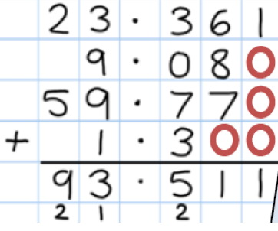  Add mixed numbers and fractions with different denominators. | Derive swiftly and without difficulty, number bonds to 100  Use place value and number facts to add friendly large or decimal numbers, e.g. 3.4 + 6.6 or 26,000 + 5,400  Use column addition to add larger numbers.  Use column addition to add decimal numbers, including money.
 | Subtraction | Use number bonds to 100 to perform mental subtraction of any pair of integers by complementary addition. (E.g. 1000 – 654 as 46 + 300 in our heads  Use number bonds to 1 and 10 to perform mental subtraction of any pair of one-place or two-place decimal numbers using complementary addition and including money. (E.g. 10 – 3.65 as 0.35 + 6, £50 – £34.29 as 71p + £15)  Use number facts and place value to perform mental subtraction of large numbers or decimal numbers with up to two places. (E.g. 467,900 – 3,005 or 4.63 – 1.02)  Subtract multiples of powers of ten and near multiples of the same.  Subtract negative numbers in a context such as temperature where the numbers make sense. | Use column subtraction to subtract numbers with up to 6 digits - using the language of ‘exchange’ and denes equipment to support this concept when bridging through a ten.  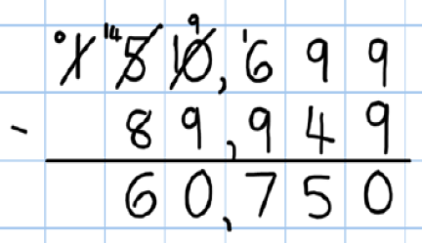  Use complementary addition for subtractions where the larger number is a multiple or near multiple of 1000 or 10,000.  Use complementary addition for subtractions of decimal numbers with up to three places including money.  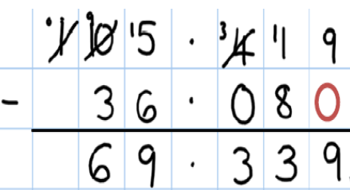  Subtract mixed numbers and fractions with different denominators. | Use number bonds to 100 to perform mental subtraction of numbers up to 1000 by complementary addition. (E.g. 1000 – 654 as 46 + 300 in our heads.)  Use complementary addition for subtraction of integers up to 10,000. E.g. 2504 – 1878 as  +2 +20 +100 +504 = 626  1878 1880 1900 2000 2504  Use complementary addition for subtractions of one-place decimal numbers and amounts of money. (E.g. £7.30 – £3.55 as  +5p +40p +£3.30 = £3.75  £3.5 £3.60 £4.00 £7.30
 | Multiplication | Know by heart all the multiplication facts up to 12 x 12. Multiply whole numbers and decimals with up to three places by 10, 100 or 1000, e.g. 234 x 1000 = 234,000 and 0.23 x 1000 = 230)  Identify common factors, common multiples and prime numbers and use factors in mental multiplication. (E.g. 326 x 6 is 652 x 3 which is 1956)  Use place value and number facts in mental multiplication. (E.g. 40,000 x 6 = 24,000 and 0.03 x 6 = 0.18)  Use doubling and halving as mental multiplication strategies, including to multiply by 2, 4, 8, 5, 20, 50 and 25 (E.g. 28 x 25 is ¼ of 28 x 100 = 700)  Use rounding in mental multiplication. (34 x 19 as (20 x 34) – 34)  Multiply one and two-place decimals by numbers up to and including 10 using place value and partitioning. (E.g. 3.6 x 4 is 12 + 2.4 or 2.53 x 3 is 6 + 1.5 + 0.09)  Double decimal numbers with up to 2 places using partitioning e.g. 36·73 doubled is double 36 (72) plus double 0·73 (1·46) | Use short multiplication to multiply a 1-digit number by a number with up to 4 digits  Use long multiplication to multiply a 2-digit by a number with up to 4 digits  Use short multiplication to multiply a 1-digit number by a number with one or two decimal places, including amounts of money.  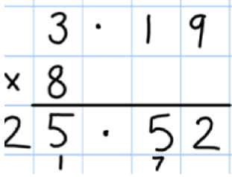  Multiply fractions and mixed numbers by whole numbers.  Multiply fractions by proper fractions.  Use percentages for comparison and calculate simple percentages. | Know by heart all the multiplication facts up to 12 x 12.  Multiply whole numbers and one-and two-place decimals by 10, 100 and 1000.  Use an efficient written method to multiply a one-digit or a teens number by a number with up to 4-digits by partitioning (grid method).  Multiply a one-place decimal number up to 10 by a number ≤100 using grid method.
 | Division | Know by heart all the division facts up to 144 ÷ 12.  Divide whole numbers by powers of 10 to give whole number answers or answers with up to three decimal places.  Identify common factors, common multiples and prime numbers and use factors in mental division. (E.g. 438 ÷ 6 is 219 ÷ 3 which is 73)  Use tests for divisibility to aid mental calculation.  Use doubling and halving as mental division strategies, e.g. to divide by 2, 4, 8, 5, 20 and 25. (E.g. 628 ÷ 8 is halved three times: 314, 157, 78.5)  Divide one and two place decimals by numbers up to and including 10 using place value. (E.g. 2.4 ÷ 6 = 0.4 or 0.65 ÷ 5 = 0.13, £6.33 ÷ 3 = £2.11)  Halve decimal numbers with up to 2 places using partitioning. e.g. Half of 36·86 is half of 36 (18) plus half of 0·86 (0·43)  Know and use equivalence between simple fractions, decimals and percentages, including in different contexts.  Recognise a given ratio and reduce a given ratio to its lowest terms. | Use short division to divide a number with up to 4 digits by a 1-digit or a 2-digit number including decimals.  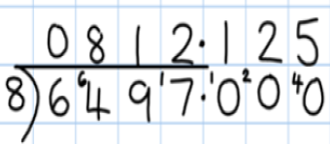  Use long division to divide 3-digit and 4-digit numbers by ‘friendly’ 2-digit numbers.  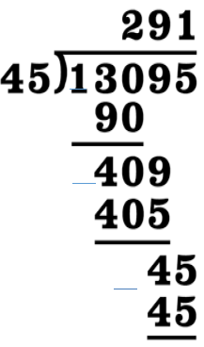  Give remainders as whole numbers or as fractions or as decimals  Divide a one-place or a two-place decimal number by a number ≤ 12 using multiples of the divisors.  Divide proper fractions by whole numbers. | Know by heart all the division facts up to 144 ÷ 12.  Divide whole numbers by 10, 100, 1000 to give whole number answers or answers with up to two decimal places.  Use efficient chunking involving subtracting powers of 10 times the divisor to divide any number of up to 1000 by a number ≤ 12.  (E.g. 836 ÷ 11 as 836 – 770 (70x11) leaving 66 which is 6x11. So that we have 70 + 6 = 76 as the answer).  Divide a one-place decimal by a number ≤10 using place value and knowledge of division facts.  .

